RC tutorial <3-digit number here> - <Title here>

=======================================================

Revised 2019-09-30

* This tutorial's goal is to teach you < the subject here>.
* Assumed RailCOMPLETE skills: <None | Previous lessons | etc>.
* Assumed railway skills: You know about < etc >.
* Time to spend here: Intermediate: <estimated duration>.
* Notice to users with non-English versions of AutoCAD – see footnote[1].
* This tutorial was prepared using software release 2018.22.1284 with Norwegian DNA version “2019.1 gamma”,”NO-BN;NO-0001;2019-09-28T20:19:00+01:00;2019.1”.
* Note: If you are using AutoCAD version 2017 or older, then open the 2013-format version of the tutorial DWG file.

<A nice illustration here:>

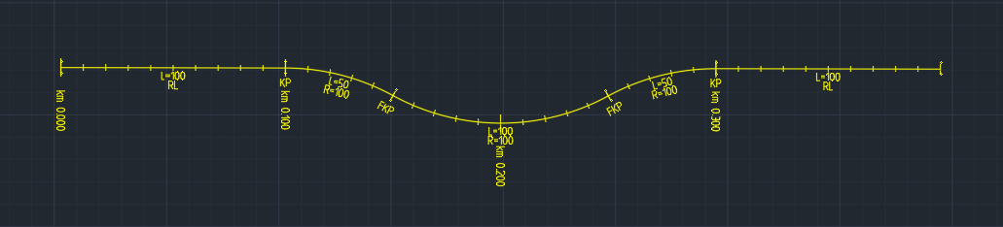

1. Start AutoCAD with RailCOMPLETE, then open the ‘General Tutorials’ folder and locate the DWG file named after this tutorial. You can either type RC-ShowGeneralTutorials or you can locate the button below the RC logo in the upper left corner of your AutoCAD window.
2. Locate the yellow line just above this text. It is called <etc>.
3. Blah blah blah.

Please check our website www.railcomplete.com for updates.

Corrections and suggestions are welcome to support@railcomplete.no.

Thank you for using RC Tutorials!

1. Your AutoCAD session has probably been started from a Windows shortcut of the type:  
   “C:\Program Files\Autodesk\AutoCAD 2019\acad.exe” /product ACAD /language “fr-FR” or similar (“fr-FR” means “French language, France’s version). Native AutoCAD commands may have different names in your language pack, other than the COPY, COPYBASE, FIND etc that you see in our tutorial texts. In order to instruct AutoCAD to accept the native English command name, precede the native (English) command name by an underscore character, ‘_’. For instance: ‘_FIND’ will start AutoCAD’s native ‘FIND’ command even if you are using AutoCAD with the French language pack, where the command in French is called ‘RECHERCHER’.If a command needs an argument ‘ON’, and the French menu says ‘Allumer’, then you can enter ‘_ON’ to instruct AutoCAD to use the option’s native name.